The UDP Band Map
Aki Yoshida JA1NLX

UDP BandMap Gridsquare column width

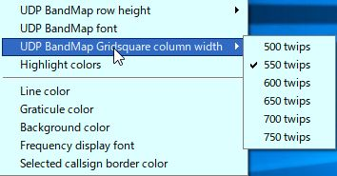

UBM_10A

Click "Highlight colors" to configure Gridsquare highlight colors and UDP BandMap text color. If you prefer to see bold text for callsign who have called CQ then check "Show bold text who have called CQ"
.

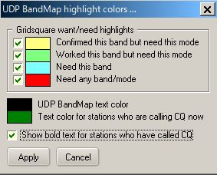

new UBM-11

Sample below. The stations who are calling CQ now are displayed in Green text, the stations who have called CQ are displayed in white black/bold text and the stations who are working other stations are displayed in white black text.

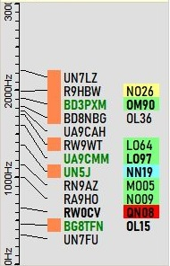

new UBM_11A

5.2. Clear

